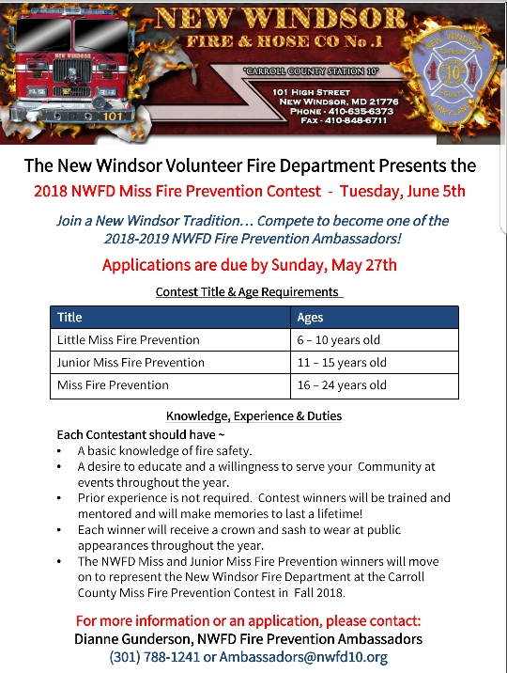

All applications must be received by Sunday, May 27, 2018!

Miss New Windsor Fire Prevention Contests
2018– 2019 Rules

The New Windsor Fire and Hose Company sponsors a Miss New Windsor Fire Prevention program each year. Each winner will represent the New Windsor Fire and Hose Company at local fire department events, parades, and public education events. In addition the winner of the Miss Fire Prevention and Jr. Miss Fire Prevention contest will go on to represent New Windsor at the Miss Carroll County Fire Prevention contest in the Fall 2018.

Rules:
- Contestants must be single, never married, and have no children or be pregnant.
- Age Requirements
  - Little Miss – 6 to 10 years of age
  - Junior Miss – 11 to 15 years of age
  - Miss – 16 to 24 years of age
- Each contestant will be interviewed by a panel of three judges.
- Contest judges will not be members or employees of the New Windsor Fire and Hose Company.
- Contestants will be judged on the following:
  - General Presentation
  - Speaking Ability
  - Fire Prevention Knowledge and Presentation
- Applications must be received by the New Windsor Fire and Hose Company’s Miss Fire Prevention chair by Sunday, May 27, 2018.
- This is not a talent or beauty contest
- Judges’ decision is final
- Attire
  - Little Miss – Dress (“Sunday best” attire)
  - Jr. Miss and Miss – Business attire for interview, Gown for stage portion
- Any Fire Prevention representative under the age of 18 must be accompanied by a parent or guardian at all events they attend.
- Contestants must live within Carroll County. Contestants may not compete for the title of Miss New Windsor Fire Prevention if their first due fire department sponsors a Miss Fire Prevention contest for their age group.
- Contestants may not hold any other Miss Fire Prevention titles at the time they are competing.
- Contestants may not have previously held the Carroll County Fire Prevention Title for the age group in which they intend to compete in.

Each winner will receive a crown and sash to be worn at public appearances throughout the year.

All applications must be received by Sunday, May 27, 2018!

Miss New Windsor Fire Prevention Contest
Application

Check Level: _______ Little Miss _________ Junior Miss ________Miss

Name____________________________________ Date of Birth _______________

Address: ______________________________________________________________

______________________________________________________________________

Home Phone: _____________________ Cell Phone: ______________________

E-mail: ________________________________________________________________

School you attend (if applicable): ___________________________________________

Community and extra curricular activities: ____________________________________

______________________________________________________________________

______________________________________________________________________

______________________________________________________________________

Hobbies: ______________________________________________________________

______________________________________________________________________

______________________________________________________________________

I have read the attached rules and guidelines provided to me. If chosen, I agree to those rules.

________________________________ __________________
Signature Date

________________________________ ___________________
Parent Signature Date
(if under 18 years of age)

Please return completed applications to Dianne Gunderson, New Windsor Miss Fire Prevention Chair via Email to Ambassadors@nwfd.org or Mail to: New Windsor Fire Department, ATTN: Dianne Gunderson, 101 High Street, New Windsor, MD 21776
All applications must be received by Sunday, May 27, 2018!

Contest Guidelines
Date: Tuesday, June 5, 2018 - Start Time TBD on number of Contestants
Location: Windsor Station, NWFD Social Hall

Little Miss
- Each contestant will present a drawing they have completed that shows a fire safety message that they think is important. Topics may include, but are not limited to: Don’t Play with Matches; Stop, Drop, and Roll; Knowing what number to call in case of emergency; Firefighters are your friends; etc.
- These drawings will be presented to the judges in an individual interview where the young ladies will be asked to talk about their drawings and answer the question “Why do you want to be Little Miss New Windsor Fire Prevention?”
- For the onstage portion, the young ladies will pick one of the following fire prevention questions from random and asked to give their answer to it:
  - What number should you call if your house catches on fire?
  - What information should you have ready to give to the 911 operator?
  - Why is important to practice safe ways out of your house before a fire occurs?
  - What would you do if your clothes catch on fire?
  - Why should all families have a meeting place? Where should it be?
  - What should you do if you find matches sitting on a table or counter?
  - What are some hot items in your house? Why shouldn’t you touch them?

Junior Miss and Miss
- Each contestant should have a 3-5 minute presentation prepared to share with the judges during a personal interview. This presentation may use props or posterboards, but may not be a PowerPoint as a computer will not be available. This presentation may be on any fire prevention topic that the contestant believes is important. If you have any questions, please feel free to contact the New Windsor Fire Prevention committee.
- For the stage portion, both Junior Miss and Miss contests will be asked the question: How do you hope to spread the fire prevention message? They will each then pull one of the following questions at random and judged on their answer to it.
  - When you are speaking to a group of babysitters, what do you believe are the most important items of information they should know?
  - When you enter a public place or stay at a hotel, what are the things you should note in the event of a fire?
  - What fire safety procedures should be employed with fireplaces, stoves, and portable space heaters?
  - Why are planned escape routes and fire drills so important?
  - When speaking to a group of campers, what precautions must you give them to ensure a fire safe environment in order to prevent forest fires?
  - When speaking to a community groups about kitchen fires, what precautions would you give them to prevent kitchen fires?
  - We know residential sprinklers save lives and property. How would you promote their use?
  - Where should smoke alarms be placed in the home and how often should they be tested?
  - Explain the proper use of a fire extinguisher and when should or shouldn’t you use one.
  - What is the importance of education people of all ages in fire safety?
  - Describe an electrical octopus hazard and explain how electrical appliances can be safely used in the home.
  - When using outdoor cooking devices (gas or charcoal grills) when should you use these grills and what precautions should you take with them?

RESOURCES

Maryland Life Safety Information Exchange
www.mdlifesafety.org

U.S. Fire Administration
www.usfa.fema.gov

National Fire Protection Association (NFPA)
www.nfpa.org/Public-Education

